|  |  |
| --- | --- |
| **Course Title** | Database Architecture |
| **Project Code** | SQAE v1-2 Project 2005-0721 |
| **Project Title** | |  | | --- | | MultiLease Management System Part 1 | |
| **Insitution** | CDI College |
| **Project done by** | Barsha Shaikh |
| **Student ID** | 635-201244 |
| **Date Completed** | February 3, 2021 |

1.

|  |  |  |  |  |
| --- | --- | --- | --- | --- |
| **Entity Relationship Diagram - MultiLease Management System** | | | | |
| **Entities:** | Customer, Vehicles and Lease | |  |  |
| **Relationships:** | Indicated in Blue |  |  |  |
| **Primary Keys:** | Indicated in Pink |  |  |  |
| **Foreign Keys:** | Indicated in Green |  |  |  |

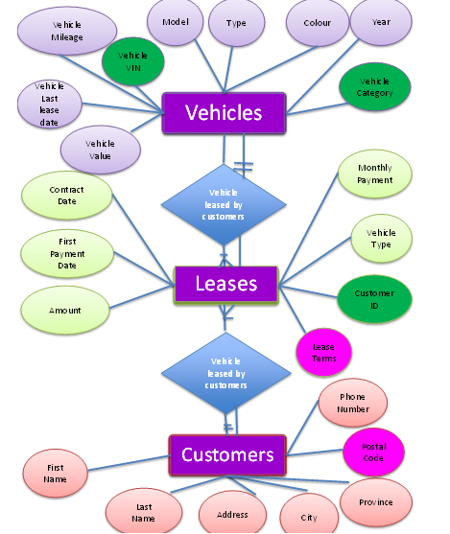

2 and 3.

CREATE DATABASE ML01244;

USE ML01244;

CREATE TABLE Customers (

id INT NOT NULL AUTO_INCREMENT,

first_name VARCHAR (45),

last_name VARCHAR (45),

address VARCHAR (45),

city VARCHAR (45),

province VARCHAR (45),

postal_code VARCHAR (15),

phone_num VARCHAR (15),

PRIMARY KEY (id)

);

CREATE DATABASE ML01244;

USE ML01244;

CREATE TABLE Vehicles (

VIN VARCHART(7) NOT NULL,

model VARCHAR (45),

type VARCHAR (45),

colour VARCHAR (45),

year VARCHAR (15),

v_mileage VARCHAR (45),

v_lease_date VARCHAR (15),

book_value VARCHAR (15),

v_cat VARCHAR(15),

PRIMARY KEY (VIN),

FOREIGN KEY (v_cat) REFERENCES vehicle category(v_cat)

);

CREATE DATABASE ML01244;

USE ML01244;

CREATE TABLE Leases (

lease_id INT NOT NULL AUTO_INCREMENT,

monthly_payment VARCHAR (45),

v_type VARCHAR (45),

cust_id INT NOT NULL,

contract_date VARCHAR (15),

first_payment_date VARCHAR (45),

amount VARCHAR (15),

v_value DECIMAL (6,2),

PRIMARY KEY (lease_id),

FOREIGN KEY (VIN) REFERENCES vehicles(VIN)

FOREIGN KEY (v_last_lease_date) REFERENCES vehicle last lease date(v_last_lease_date)

);

CREATE DATABASE ML01244;

USE ML01244;

CREATE TABLE Lease Terms (

num_year VARCHAR (15),

max_mileage VARCHAR (45),

extra_mileage VARCHAR (45),

contract_date VARCHAR (45),

payment_date VARCHAR (45),

monthly_payment VARCHAR (45),

payment_num VARCHAR (45),

vehicle_type VARCHAR (45),

cust_name VARCHAR (45),

l_term VARCHAR (45),

PRIMARY KEY (num_year),

FOREIGN KEY (VIN) REFERENCES vehicles (VIN)

);

CREATE DATABASE ML01244;

USE ML01244;

CREATE TABLE Payments (

lease_id INT NOT NULL AUTO_INCREMENT

p_date VARCHAR (45),

change_field VARCHAR (45),

amount VARCHAR (15),

PRIMARY KEY (lease_id),

FOREIGN KEY (p_date) REFERENCES payment date(p_date)

);

CREATE DATABASE ML01244;

USE ML01244;

CREATE TABLE Audits (

lease_id INT NOT NULL AUTO_INCREMENT

change_date VARCHAR (45),

change_field VARCHAR (45),

oldvalue_field VARCHAR (15),

newvalue_field VARCHAR (15),

PRIMARY KEY (lease_id),

FOREIGN KEY (change_date)

);

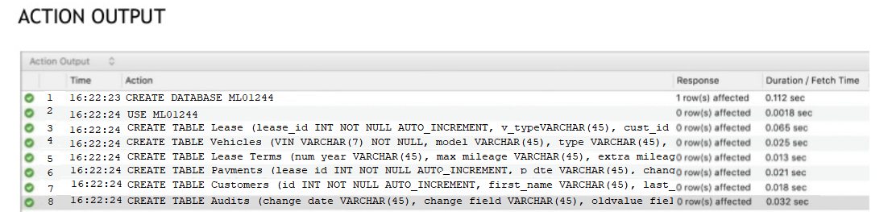

**4.**

lease_id

change_date

change_field

oldvalue_field

newvalue_field

**Audits**

Monthly_Payment

Vehicle_Type

Customer_ID

Lease_Terms

Contract_Date

First_Payment_Date

Amount

**Leases**

Vehicle_VIN

Model

Type

Colour

year

v_mileage

v_lease_date

book_Value

v_cat

**Vehicles**

lease_id

p_date

change_field

**Payments**

num_year

max_mileage

extra_mileage

**Lease Terms**

**Customers**

First_Name

Last_Name

Address

City

Province

Postal_Code

Phone_Num

**5.**

**--INSERTING INTO Vehicles (VIN, model, type, colour, year, v_mileage, v_lease_date, book_value, v_cat) VALUES**

(“3W9T1-2Q10D-12D0P-2E1R2”, “2003 SC-430”, “2dr Coupe”, “Deep Blue”, “2003”, “120,000km”, “2004-01-15”, “$90,000”, “Auto”),

(“7D901-9W120-Z0029-021P2”, “200 Pirate”, “2dr Coupe”, “Racey Red”, “2000”, “85,000km”, “2004-03-16”, “$45,000”, “Manual”),

(“Z1221-X129A-KO212-9021J”, “2003 Expensive”, “4dr Sedan”, “Lemon Yellow”, “2003”, “90,000km”, “2004-01-15”, “$90,000”, “Auto”),

(“3W9T1-2Q10D-12D0P-2E1R2”, “2003 SC-430”, “2dr Coupe”, “Deep Blue”, “2003”, “150,000km”, “2004-04-01”, “$70,000”, “Auto”),

(“M21L1-3129S-V1292-L12X1”, “2001 Rock”, “Truck”, “Silver Grey”, “2001”, “130,000km”, “2002-02-20”, “$85,000”, “Manual”),

(“M21L-3129S-V1292-L12X1”, “2001 Rock”, “Truck”, “Silver Grey”, “2001”, “150,000km”, “2004-07-01”, “$45,000”, “Manual”),

----------------------------------------------------------------------------

**--INSERT INTO Customers (first_name, last_name, address, city, province, postal_code, phone_num) VALUES**

(“Candie”, “Wrapper”, “1000 Lollipop Lane”, “Halifax”, “NS”, “B1X 1X1”, “902-123-4567”),

(“Scalli”, “Wag”, “80 Plank Walk”, “Halifax”, “NS”, “B2L 1L1”, “902-812-4567”),

(“Inna”, “Chambers”, “2 Politician Street”, “Halifax”, “NS”, “B3M 1M1”, “902-341-4212”),

(“Multi Lease”, “Corp”, “1200 Motor Way”, “Halifax”, “NS”, “B5A 1K1”, “902-821-4319”),

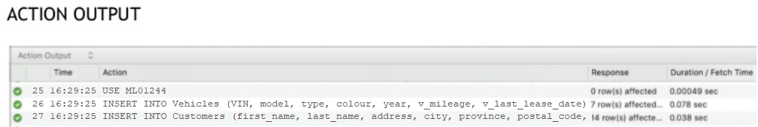

**6. Database – Test Data**

3 Customers:

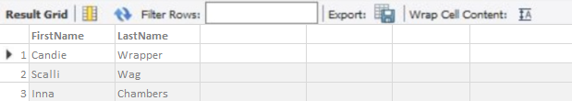

5 Leases with appropriate leasing terms:

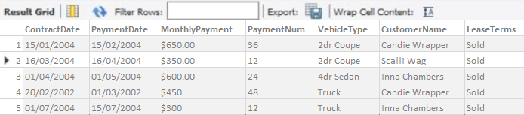

5 models, types and colours:

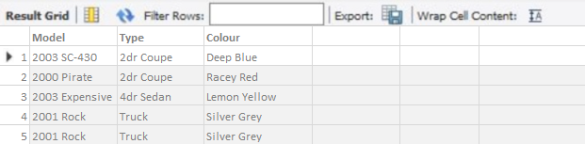

4 Vehicles:

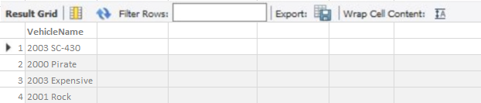

**7. List of Customers:**

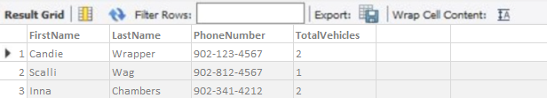

**8. List of Vehicles:**

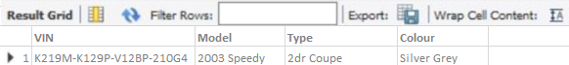

**9. List of Vehicles that have air conditioning and power locks:**

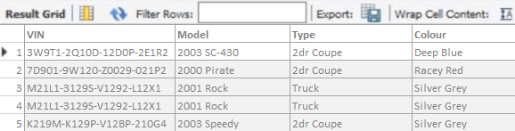

**10. List of Vehicles with the largest maximum kilometres:**

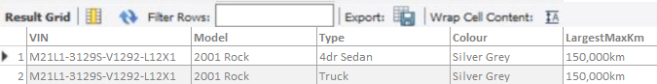

**11. Database ML_01244 and ML_Employees**

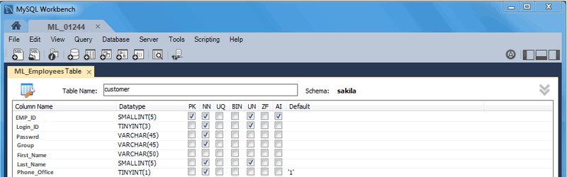

**Group in SQL Server**

